ROSSMOYNE SENIOR HIGH SCHOOL

Semester Two 2011

Trial WACE Examination, 2011

Question/Answer Booklet

MATHEMATICS 3A/3B

Section One:

Calculator-Free

NAME:
TEACHER: Benko Fletcher Goh Longley Pui

(Circle one name) Rigelsford Robinson Tanday Tay White Whyte

Time allowed for this section
Reading time before commencing work: five minutes
Working time for this section: fifty minutes

Materials required/recommended for this section

To be provided by the supervisor
This Question/Answer Booklet
Formula Sheet

To be provided by the candidate
Standard items: pens, pencils, pencil sharpener, eraser, correction fluid/tape, ruler, highlighters

Special items: nil

Important note to candidates

No other items may be used in this section of the examination. It is your responsibility to ensure that you do not have any unauthorised notes or other items of a non-personal nature in the examination room. If you have any unauthorised material with you, hand it to the supervisor before reading any further.

Structure of this paper

Section | Number of questions available | Number of questions to be answered | Working time (minutes) | Marks available | Percentage of exam
Section One:  Calculator-free | 7 | 7 | 50 | 40 | 33
Section Two:  Calculator-assumed | 13 | 13 | 100 | 80 | 67
 |  |  | Total | 120 | 100

Instructions to candidates

- The rules for the conduct of Western Australian external examinations are detailed in the Year 12 Information Handbook 2011. Sitting this examination implies that you agree to abide by these rules.

- Write your answers in the spaces provided in this Question/Answer Booklet. Spare pages are included at the end of this booklet. They can be used for planning your responses and/or as additional space if required to continue an answer.
- Planning: If you use the spare pages for planning, indicate this clearly at the top of the page.
- Continuing an answer: If you need to use the space to continue an answer, indicate in the original answer space where the answer is continued, i.e. give the page number. Fill in the number of the question(s) that you are continuing to answer at the top of the page.

- Show all your working clearly. Your working should be in sufficient detail to allow your answers to be checked readily and for marks to be awarded for reasoning. Incorrect answers given without supporting reasoning cannot be allocated any marks. For any question or part question worth more than two marks, valid working or justification is required to receive full marks. If you repeat an answer to any question, ensure that you cancel the answer you do not wish to have marked.

- It is recommended that you do not use pencil, except in diagrams.

Section One: Calculator-free (40 Marks)
This section has seven (7) questions. Answer all questions. Write your answers in the spaces provided.

Working time for this section is 50 minutes.

Question 1 (3 marks)
The gradient function of a curve is given by 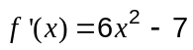. Find , given that 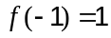.

Question 2 (5 marks)
A project manager has split a job into 9 tasks. Each needs to be completed by one worker. The time that each task requires in hours is shown in the table, together with any predecessors.

Task | A | B | C | D | E | F | G | H | J
Time (hours) | 8 | 4 | 4 | 3 | 8 | 8 | 5 | 3 | 4
Predecessor(s) | - | - | - | B, C | B, C | A, D | A, D | E, G | E, G

(a) Construct a project network to show the above information. (2 marks)

(b) List the tasks that lie on the critical path. (1 mark)

(c) Find the minimum completion time for the project and state the number of workers required to achieve this minimum time. (2 mark)

Question 3 (7 marks)
Solve the following equations for .

(a) 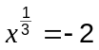 (1 mark)

(b) 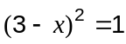 (3 marks)

(c) 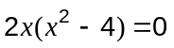 (3 marks)

Question 4 (6 marks)
(a) Sets A and B are drawn from a universal set of integers U such that 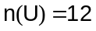, 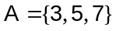 and 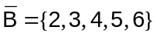. If one integer is selected at random from U, determine

(i) P(B) (1 mark)

(ii) P() (1 mark)

(iii) P(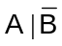) (1 mark)

(b) A bag contains five similar sized cards, each with a different digit on it. The digits are 2, 3, 4, 5 and 6. Three cards are removed at random from the bag and placed next to each other to form a number.

(i) How many different numbers can be made? (1 mark)

(ii) What is the probability that the number does not contain the digit 6? (1 mark)

(iii) What is the probability that the number is a multiple of 5, given that the first digit chosen is the 3? (1 mark)

Question 5 (9 marks)
The graph of 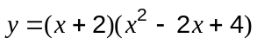 has just one root.

(a) Find the coordinates of both axes intercepts. (2 marks)

(b) Find the gradient function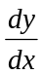, in simplified form. (3 marks)

(c) State the coordinates of the point where the slope of the curve is 0. (1 mark)

(d) Sketch the graph of . (3 marks)
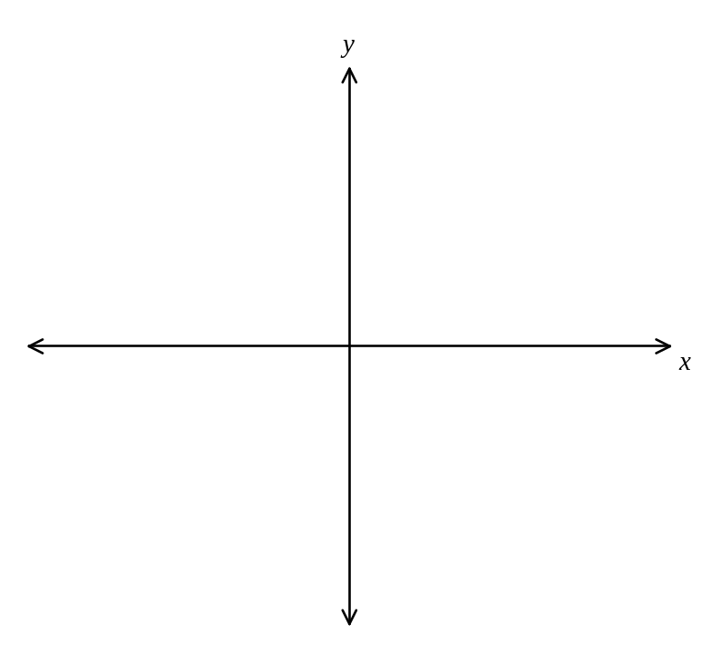

Question 6 (6 marks)
A curve has equation 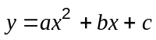. The curve has a turning point at (4, 9) and a gradient of -1 when 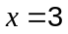. Determine the values of , and .

Question 7 (4 marks)
Consecutive integers are arranged in a four-column table as shown below.

... | ... | -3 | -2
-1 | 0 | 1 | 2
3 | 4 | 5 | 6
7 | 8 | 9 | 10
11 | 12 | ... | ...

(a) Use an example to show that the square of any number in the table is 16 more than the product of the numbers immediately above and below that number. (1 mark)

(b) Prove that the square of any number in the table is 16 more than the product of the numbers immediately above and below that number. (3 marks)

Additional working space

Question number: _________

Additional working space

Question number: _________

